**Instructions for Travel Time – Variation Routine Analysis**  
  
For this part you are required to see how the Travel time from RITIS changes between two selected dates in addition to visualization of how a specific Variation Routine is activated on those two dates and potentially seeing the impact of a variation routine on   
  
**Step1:** Identify the two dates of comparison and lower/upper time thresholds that you want to constraint the analysis to  
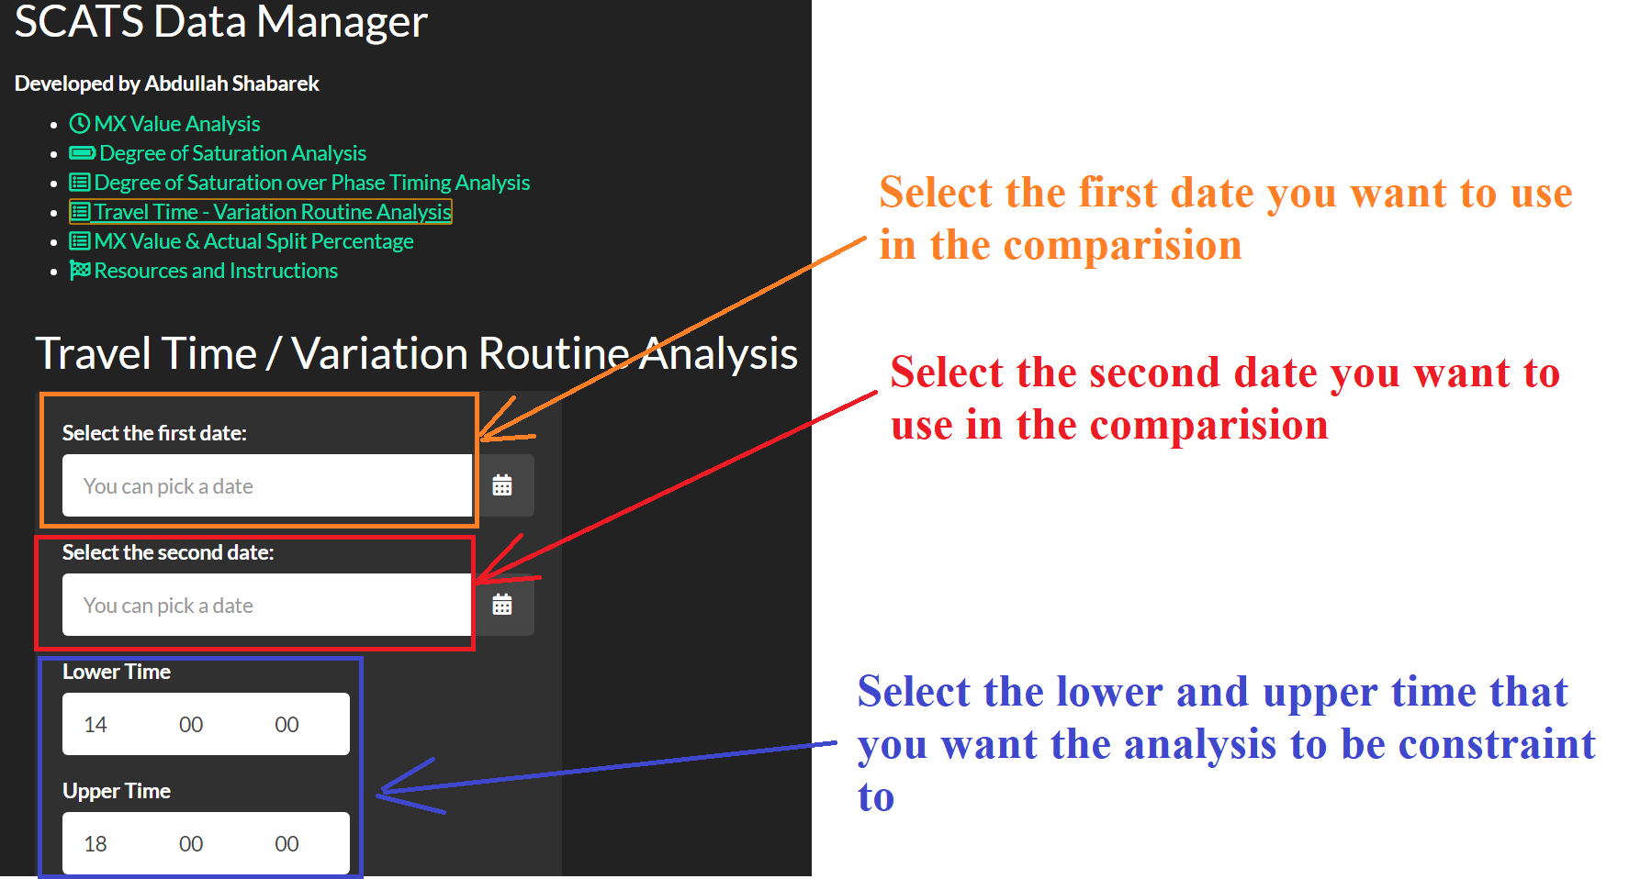

**Step2:** Type in TMCs from RITIS that belong to one direction. You may type in multiple TMCs as long as you separate them by next line (by hitting enter between the TMCs as shown below). Select the site ID and both the variation 1 (i.e., VR activation) and variation 2 (i.e., VR deactivation). You may find the VR numbers which are identical to each intersection from SCATS log.

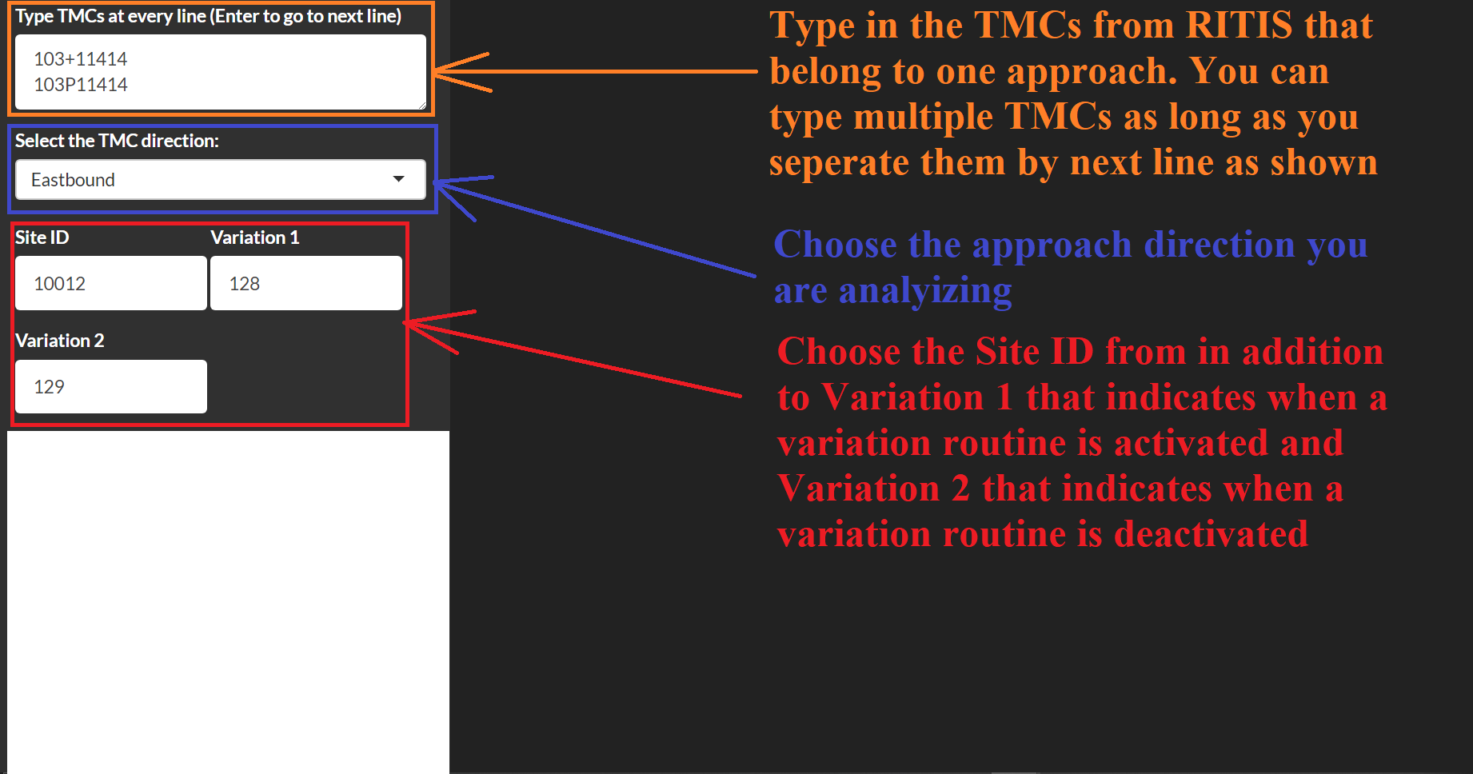

**Step3:** Go to RITIS to “Massive Data Download”. Select the segments that you are interested in and the range of dates that includes both Date 1 & Date 2 in one file.

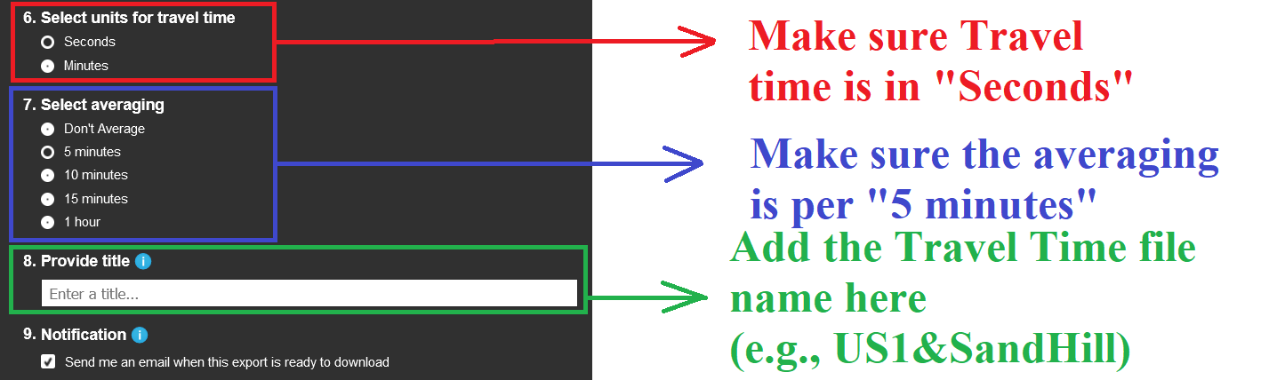

**Step 4:** From SCATS Log, you need to export the results as CSV file but make sure that the filter is checked in for “Origin” as shown below. Also, make sure you are not filtering for a specific site id that is different from the Site ID you are analyzing, as shown below. You don’t have to click enable. The website will exclude the irrelevant results automatically even if you include them.

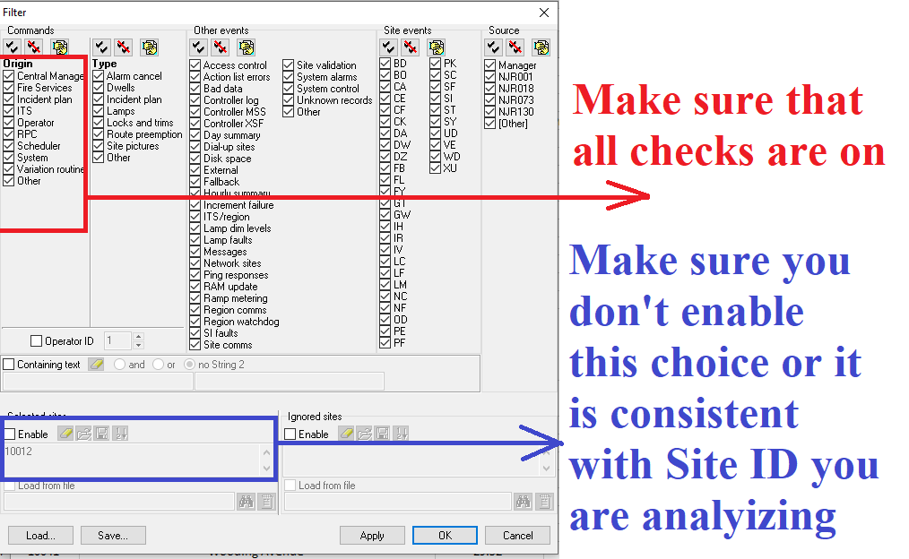

**Step5:** In case you are wondering where you get the Variation Routine # from SCATS Log

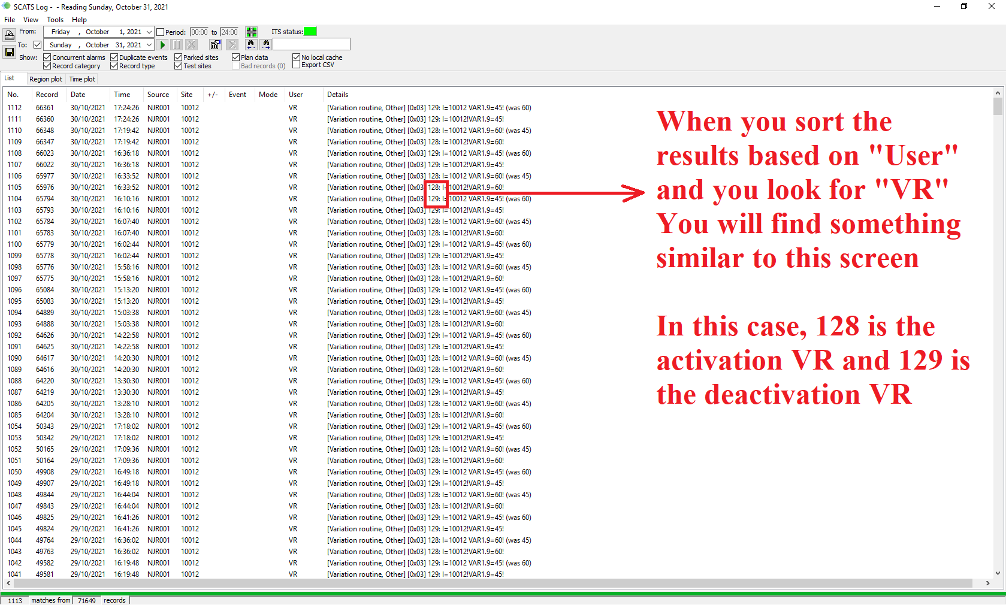

**Step6:** Go back to the website to upload the following three files as shown and illustrated below:  
